Stefan Cline

Homework #3

Math 538 – Discrete Dynamical Systems and Chaos

11 September 2021

Exercises:

1.10, 1.11, 1.12, 1.14

**Problem 1.10**

For the map $g\left(x\right)=3.05x(1-x)$, find the stability of all fixed points and period-two points.

First, we’ll go ahead and find all of the fixed points. We immediately observe that $g\left(x\right)$ is a “smooth” function as defined by the textbook. Now, we know that a point $p$ is a fixed point if $f\left(p\right)=p$. So, using $f$:

$$f\left(p\right)=3.05p\left(1-p\right)=p$$

$$3.05p-3.05p^{2}=p$$

$$2.05p-3.05p^{2}=0$$

$$p\left(2.05-3.05p\right)=0$$

So, our first fixed point is $p=0$. Also:

$$2.05-3.05p=0$$

$$3.05p=2.05$$

$$p=\frac{2.05}{3.05}=\frac{41}{61}$$

Together then the fixed points are:

$$p=0, p=\frac{41}{61}$$

Now, using Theorem 1.5, we’ll take the derivative of $f(x)$:

$$f\left(x\right)=3.05x\left(1-x\right)$$

$$=3.05x-3.05x^{2}$$

$$f^{'}\left(x\right)=3.05-6.1x$$

Now at our two fixed points:

$$\left|f^{'}\left(0\right)\right|=\left|3.05-6.1\left(0\right)\right|=\left|3.05\right|>1$$

$$\left|f^{'}\left(\frac{41}{61}\right)\right|=\left|3.05-6.1\left(\frac{41}{61}\right)\right|=\left|-1.05\right|>1$$

Hence, we see that both of our fixed points are sources as such are unstable.

Now to find our periodic points of period 2. We’ll want to iterate the function $f\left(x\right)$ twice, so $f\left(f\left(x\right)\right)$, i.e. $f^{\left(2\right)}(x)$.

$$f\left(x\right)=3.05x\left(1-x\right)$$

$$f\left(f\left(x\right)\right)=3.05\left(3.05x\left(1-x\right)\right)(1-\left(3.05x(1-x)\right))$$

Examining a graph of the above function with the $y=x$ line we can see roughly where we expect to find our period two orbits (roughly .59, .67 and .74, and obviously 0 continues to be a periodic orbit).

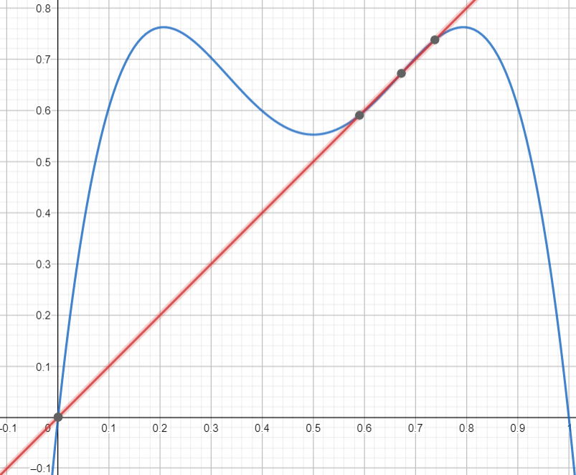

It’s clear that this function won’t have nice solutions, so we’ll use the TI-NSpire CX CAS graphing software which give us extremely accurate approximations of our period-two points (listed on the side from smallest to largest).

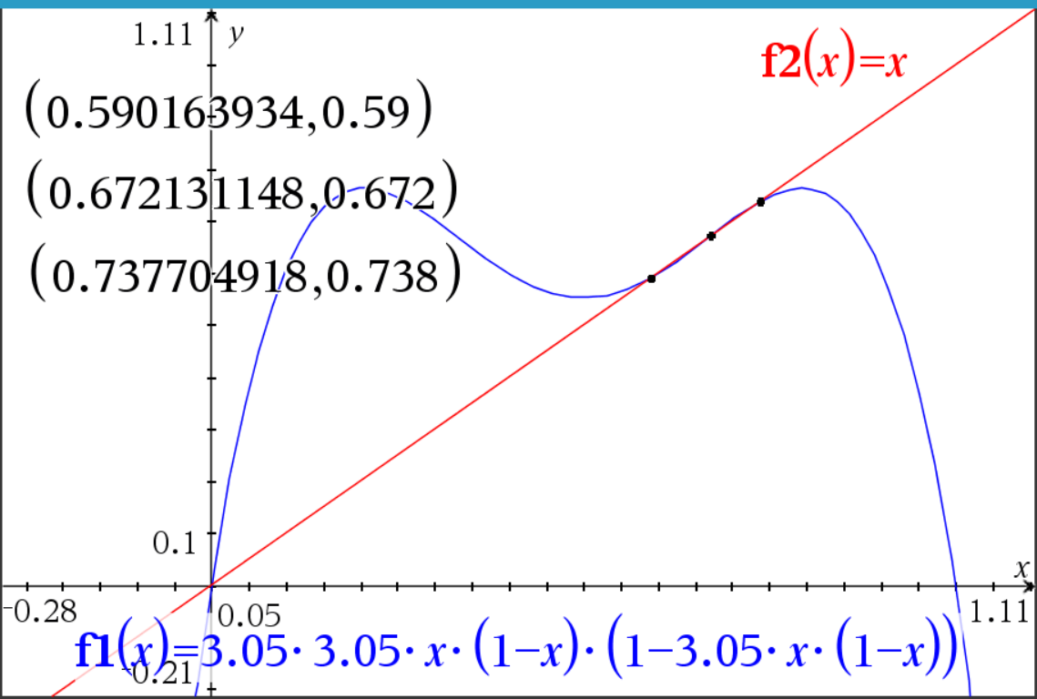

Now, in order to test the stability intuitively, we’ll perform over 2000 iterations using MS Excel.

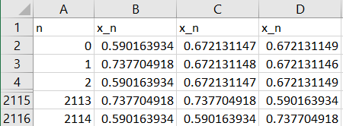

Here, we see that we expect our 0.59 and 0.74 orbits to be stable/sink when evaluated, and our 0.67 to be unstable/source which we tested by a very tiny nudge to the left and right of 0.672131148 by $±$ 0.000000001.

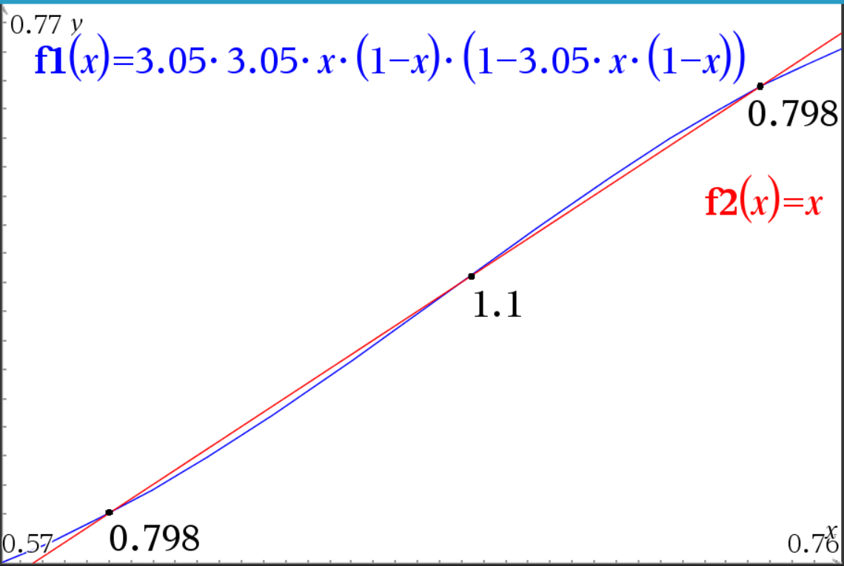

As is no surprise, zooming in on our intersection region, and using the software to calculate the derivatives at exactly those points, we see that our two derivatives are the same and less than one, such that when they’re multiplied together, we get

$$\left|f^{'}\left(0.5902…\right)f^{'}\left(0.7377…\right)\right|=\left|0.789⋅0.789\right|<1$$

As such, we confirm by the stability test for periodic orbits that those two points are stable. Now, since there are no other points remaining, we expect this point is an unstable fixed point, which we can clearly see by the derivative at that point being $1.1$.

So altogether then we have:

|  |  |
| --- | --- |
| Stable | Unstable |
| 0.590163934  0.737704918 | 0.672131148 |

**Problem 1.11**

Let $f$ be a one-to-one smooth map of the real line to itself. One-to-one means that if $f\left(x_{1}\right)=f(x_{2})$, then $x_{1}=x_{2}$. A function $f$ is called increasing if $x_{1}<x_{2}$ implies $f\left(x_{1}\right)<f(x_{2})$, and decreasing if $x_{1}<x_{2}$ implies $f\left(x_{1}\right)>f(x_{2})$.

(a) Show that $f$ is increasing for all $x$ or $f$ is decreasing for all $x$.

Let’s assume that $f$ is smooth, one-to-one, and that $f$ is not increasing. Then, that means there must be some points, $x_{1},x_{2}$ and $x_{3}$ such that $f\left(x_{1}\right)<f(x_{2})$ but also $f\left(x_{2}\right)>f(x_{3})$. Now, because $f$ is smooth, we know that by the mean value and intermediate theorem there must be some point, $x_{1}<x^{*}<x_{2}$ and $x_{2}<x^{**}<x_{3}$ such that $f\left(x^{*}\right)=f(x^{**})$. But this is a contradiction because we know that $f$ is one-to-one. Hence, we see that $f$ must be increasing for all $x$ as $x^{*}$ and $x^{**}$ were arbitrary.

We can use similar logic to show that $f$ must also be decreasing by picking two points, $x^{*}$ and $x^{**}$ such that $x_{1}<x^{*}<x_{2}<x^{**}<x_{3}$ again, where $f\left(x_{1}\right)>f\left(x_{2}\right),$ and $f\left(x_{2}\right)<f(x_{3})$. This again, by the MVT and IVT, forces two values to exist such that $f\left(x^{*}\right)=f(x^{**})$. This again leads to a contradiction because $f$ is one-to-one.

Lastly, we can observe that this implies that the function $f$ is not only increasing or decreasing, but that it is strictly increasing or decreasing as any repeated value of $f(x)$ would imply that the function is not one-to-one.

(b) Show that every orbit $\{x_{0},x_{1},x_{2},…\}$ of $f^{2}$ satisfies either $x_{0}≥x_{1}≥x_{2}≥…$ or $x_{0}≤x_{1}≤x_{2}≤…$.

Because we know that $f$ is one-to-one and smooth, we know that it must be either increasing or decreasing by part (a). Therefore, if we want to evaluate the rate of change of $f\left(f\left(x\right)\right)=f^{\left(2\right)}(x)$, i.e., ${\left(f^{\left(2\right)}\right)}^{'}\left(x\right)$, we can do so by utilizing the chain rule and our knowledge of increasing and decreasing functions. Calculating the derivative:

$${\left[f\left(f\left(x\right)\right)\right]}^{'}=f^{'}\left(f\left(x\right)\right)⋅f'(x)$$

Case 1: $f$ is an increasing function. In this case we know that the derivative of $f$ at any point will be positive or zero. Therefore, we see that $f^{'}\left(x\right)≥0$. Now, because $f(x)$ could be any value, we see that we have any possible value of $x$ in our function for $f^{'}\left(f\left(x\right)\right)$. But again, because $f$ is increasing, we have that $f^{'}\left(f\left(x\right)\right)≥0$. As such, we have a positive value, or zero, times a positive value or zero and hence we know that ${\left[f\left(f\left(x\right)\right)\right]}^{'}≥0$.

Case 2: $f$ is a decreasing function. Here, we know that if $f$ is decreasing, then it’s derivative must also be decreasing or be zero. Hence, $f^{'}\left(x\right)≤0$. Now, like in our first case, we see that if $f$ is decreasing, then regardless of the point generated by $f(x)$, we again have that $f^{'}\left(f\left(x\right)\right)≤0$. So, we now have a situation where we have two negatives times one another (or a zero times a zero or a negative). This means that again ${\left[f\left(f\left(x\right)\right)\right]}^{'}≥0$.

Now that we know ${\left[f\left(f\left(x\right)\right)\right]}^{'}≥0$ (i.e., ${\left[f^{\left(2\right)}\left(x\right)\right]}^{'}$, we can see that it’s always increasing.

Case 1: $f^{\left(2\right)}(x)>x$. In this case, we see if we select a starting condition and call it $x_{0}$, then we know that after it passes through $f(x)$ twice, we’ll land at $x_{2}$. So, $x_{0}<f^{\left(2\right)}\left(x_{0}\right)=x_{2}$. But then we, know that

$$x_{2}<f^{\left(2\right)}\left(x_{2}\right)=x_{4}$$

Therefore, we see a constant cascade of $x_{0}<x_{2}<x_{4}<…$

Case 2: $f^{\left(2\right)}(x)<x$. Here we again have a similar cascade in an opposite direction. Again calling $f^{\left(2\right)}\left(x_{0}\right)=x_{2}$, we have:

$$x_{0}>f^{\left(2\right)}\left(x_{0}\right)=x_{2}>f^{\left(2\right)}\left(x_{2}\right)=x_{4}>…$$

Which gives us, $x_{0}>x_{2}>x_{4}>…$.

Case 3: $f^{\left(2\right)}\left(x\right)=x$. This will be the trivial case where $x$ is just a fixed point. Hence, we can see that any $x_{0}$ choice is equal to $x_{2}$, which then is equal to $x_{4}$, etc. So, $x_{0}=x_{2}=x_{4}=…$.

Case 4: $f^{\left(2\right)}(x)$ is either less than or greater than $x$. Here we have an interesting situation. We know that our function iterated on itself twice always has a positive slope. Therefore, from case 3 we know that if we select an initial point of where $f^{\left(2\right)}\left(x\right)=x$ then we’re at an equilibrium point. Therefore, we can either select points that are initially greater than $x$ or less than $x$. If $x^{*}$ is the greatest equilibrium point, then we know if any point $x_{0}>x^{*}$ is selected, then it will follow case 1 or case 2 and diverge to infinity. If $x^{**}$ is the smallest equilibrium point, and we select some $x_{0}<x^{**},$ then by case 1 or case 2 depending, we’ll diverge to negative infinity. Now, say we select $x_{0}$ such that it lies between two equilibrium points, $x^{*}$ and $x^{**}$, so that $x^{*}<x_{0}<x^{**}$. Here we then have a case where we know the iterates of $f^{\left(2\right)}\left(x\right)$ will either converge to $x^{*}$ or $x^{**}$ monotonically just as in case 1 or case 2. Therefore, we again see that for any $x_{0}$ selected we’ll either have: $x_{0}<x_{2}<x_{4}<…$, or $x_{0}>x_{2}>x_{4}>…$.

With all three cases covered we see that every orbit $\{x_{0},x_{1},x_{2},…\}$ of $f^{2}$ satisfies either $x_{0}≥x_{1}≥x_{2}≥…$ or $x_{0}≤x_{1}≤x_{2}≤…$.

(c) Show that every orbit of $f^{2}$ either diverges to $+∞$ or $-∞$ or converges to a fixed point of $f^{2}$.

This now becomes trivial with part (b) being complete. Our final three cases above effectively show how the derivative of $f^{\left(2\right)}(x)$ will either force convergence to a single fixed point that’s a sink, or divergence away from fixed-point that’s a source. Therefore, we see any orbit either converges to a fixed point, or diverges to positive or negative infinity.

(d) What does this imply about convergence of the orbits of $f$?

The orbits of $f$ will also show similar complexity, and we can expect convergence or divergence depending. We can see from three simple examples that $f$ can converge to a fixed point, diverge to infinity or positive infinity based off a selection of $x_{0}=0.5$.

$$x_{n+1}=x_{n}-2$$

Here we clearly see that successive $x_{n+1}$ values get more and more negative and diverge to $-∞$.

$$x_{n+1}=x_{n}+1$$

With the same $x_{0}$ we see divergence to positive infinity.

$$x_{n+1}=e^{-x_{n}}$$

Converges to a value around 0.56714329. All three of the above are strictly increasing/decreasing functions.

Hence, our three examples, as well as our analysis of $f^{\left(2\right)}$ give us proof of the complex behavior of $f$ even with large constraints of being one-to-one and smooth.

**Problem 1.12**

The map $g\left(x\right)=2x(1-x)$ has negative values for large $x$. Population biologists sometimes prefer maps that are positive for positive $x$.

(a) Find out for what value of $a$ the map $h\left(x\right)=axe^{-x}$ has a superstable fixed point $x_{0}$, which means that $h\left(x_{0}\right)=x_{0}$ and $h^{'}\left(x_{0}\right)=0$.

Starting we’ll first find the $h\left(x_{0}\right)=x_{0}$ relationship:

$$ax_{0}e^{-x_{0}}=x_{0}$$

$$ae^{-x_{0}}=1$$

$$e^{-x_{0}}=\frac{1}{a}$$

$$-x_{0}=\ln\left(\frac{1}{a}\right)$$

$$x_{0}=-\ln\left(\frac{1}{a}\right)$$

Now, to find $h^{'}\left(x\right):$

$$h\left(x\right)=axe^{-x}$$

$$h^{'}\left(x\right)=ae^{-x}-axe^{-x}$$

Setting this to zero and plugging in our value for $x_{0}$:

$$0=ae^{-\left(-\ln\left(\frac{1}{a}\right)\right)}-a\left(-\ln\left(\frac{1}{a}\right)\right)e^{-\left(-\ln\left(\frac{1}{a}\right)\right)}$$

$$0=ae^{\ln\left(\frac{1}{a}\right)}+a⋅\ln\left(\frac{1}{a}\right)e^{\ln\left(\frac{1}{a}\right)}$$

$$0=1+\ln\left(\frac{1}{a}\right)$$

$$-1=\ln\left(\frac{1}{a}\right)$$

$$e^{-1}=\frac{1}{a}$$

$$a=e$$

(b) Investigate the orbit starting at $x_{0}=0.1$ for this value of $a$ using a calculator. How does the behavior of this orbit differ if $a$ is increased by 50%?

We’ll be computing these in MS Excel.

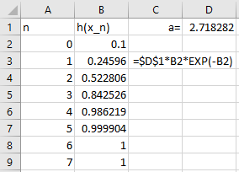

We see that at this value of $a$, we converge nicely to $h\left(x_{n}\right)=1$ as $n$ increases.

Now for $a$ increased by 50%:

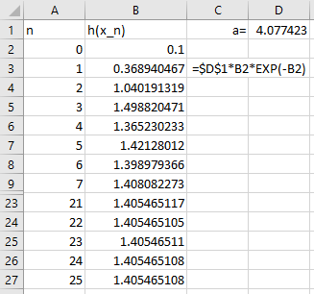

We see that it takes a much longer time for the orbit to converge and it converges to $-\ln\left(\frac{1}{1.5e}\right)$.

(c) What is the range of $a≥1$ for which $h(x)$ has a positive sink?

We know that a sink occurs at a fixed point, and we found that above to be: $x_{0}=-\ln\left(\frac{1}{a}\right)$. We also know that $a=e$ produces $f^{\left(k\right)}\left(x\right)=1$ for all $k∈Z^{+}$. Now, assuming we always pick $x_{0}$ as above, then we can see that:

$$h\left(x_{0}\right)=axe^{-x}$$

$$=a\left(-\ln\left(\frac{1}{a}\right)\right)e^{-\left(-\ln\left(\frac{1}{a}\right)\right)}$$

$$=a\left(-\ln\left(\frac{1}{a}\right)\right)e^{\ln\left(\frac{1}{a}\right)}$$

$$=-\ln\left(\frac{1}{a}\right)$$

We can see this value will be positive so long as $a≠1$ as the natural log of $1$ is zero. Therefore, we end up with $a∈(1,∞)$ produces positive sinks. This is supported by our calculations using the above:

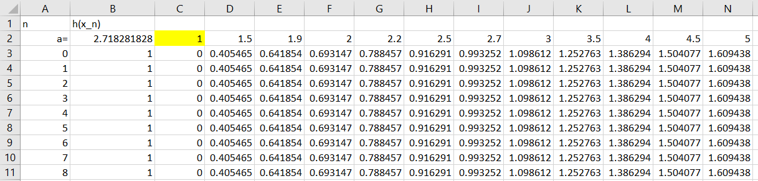

**Problem 1.14**

Let $f\left(x\right)=x^{2}+x$. Find all fixed points of $f$. Where do nonfixed points go under iteration by $f$?

To find a fixed point we’ll need to evaluate when $f\left(p\right)=p$. So:

$$f\left(p\right)=p^{2}+p=p$$

$$p^{2}=0$$

$$p=0$$

Hence, the only fixed point of $f$ is at $0$.

Now, by simple observation we can see that any positive $x_{0}$, will yield continuously increasing positive values, so before any analysis we can expect that we have a source at $p=0$ if $x_{0}>0$.

However, it’s less clear what happens when $x_{0}$ is negative.

$$f^{'}\left(x\right)=2x+1$$

$$\left|f^{'}\left(0\right)\right|=\left|2\left(0\right)+1\right|=|1|$$

So, we’ll add both a small positive and negative perturbation to $x=0$. Let $\left|ζ\right|≪1$.

$$\left|f^{'}\left(x+ζ\right)\right|=\left|2\left(0+ζ\right)+1\right|=\left|2ζ+1\right|>1$$

As expected, we have a source for positive values around $x=0$.

$$\left|f^{'}\left(x-ζ\right)\right|=\left|2\left(0-ζ\right)+1\right|=\left|(-2ζ)+1\right|<1$$

So clearly, we have a sink for negative values around $x=0$.

Now, for any values that are positive we have growth without bound. We can see this by doing one iteration and establishing the pattern.

$$f\left(x\right)=x^{2}+x$$

$$f^{\left(2\right)}\left(x\right)={\left(x^{2}+x\right)}^{2}+\left(x^{2}+x\right)$$

If $x>0$, then

$$x^{2}+x<{\left(x^{2}+x\right)}^{2}+\left(x^{2}+x\right)$$

This pattern will continue for further iterations of the dynamical system. So, we see for any $x_{0}>0$, $f^{\left(k\right)}\left(x\right)→+∞$.

Examining the special case of negative 1, we see that:

$$f\left(x\right)=x^{2}+x={\left(-1\right)}^{2}+\left(-1\right)=0$$

And we know that $0$“acts like” a fixed point. Hence, $x_{0}=1→0$ for $f^{\left(k\right)}(x)$ for all $k∈Z^{+}$.

Now, let’s observe values slightly less than and greater than negative 1. We have:

$$f^{'}\left(x\right)=2x+1$$

$$\left|f^{'}\left(-1\right)\right|=\left|2\left(-1\right)+1\right|$$

$$=\left|-1\right|=1$$

Again, we let $\left|ζ\right|≪1$. Starting with greater than:

$$|f'\left(-1+ζ\right)|=\left|2\left(-1+ζ\right)+1\right|$$

$$=\left|-2+2ζ+1\right|$$

$$=\left|-1+2ζ\right|<1$$

We can see that this number will be a very small nudge to the right of $x=-1$. So, we can determine that any value $x>-1$ will be attracted to zero.

Now for values slightly less than $-1$:

$$|f'\left(-1-ζ\right)|=\left|2\left(-1-ζ\right)+1\right|$$

$$=\left|-2-2ζ+1\right|$$

$$=\left|-1-2ζ\right|>1$$

Here, we can see that for values $x_{0}<-1$ we’ll have divergence to positive infinity.

Altogether then we have:

|  |  |
| --- | --- |
| Interval/Point for $x_{0}$ | Long Term Behavior |
| $$x_{0}>0$$ | $$+∞$$ |
| $$x_{0}=0$$ | $$0$$ |
| $$x_{0}∈(-1,0)$$ | $$0$$ |
| $$x=-1$$ | $$0$$ |
| $$x<-1$$ | $$+∞$$ |